The museums in Britain, large and small, let people recognize and understand what art and design are, and at the same time, let people realize that human art plays an irreplaceable role in life. This week, the teacher led us to visit The Design Museum, the world's first museum with design as its theme, and its exterior architecture is very modernistic. Everyone can enjoy art and design and feel excited for the resonance of the soul.

There are many surrealist works in the exhibition hall that impressed me deeply, surrealism is an artistic and literary movement that emerged in the early 1920s, characterized by its exploration of the subconscious mind and the use of dream-like imagery, unexpected juxtapositions, and other unconventional techniques. It is considered to be a continuation of the Dada movement, which had preceded it and also challenged traditional artistic and cultural norms.

One of the most interesting works is Quadriga's painting. This painting was exhibited at the 1936 International Surrealist Exhibition in London. Artist Eileen Agar was one of the few British women included in the show. Quadriga was inspired by a holograph of an ancient Greek horse's head, which Agar repeated and transformed four limes. Her approach questions the traditional presentation of classical motifs as static and perfect. A similarly subversive treatment of classical sculpture is found in works by Agar's contemporaries Dali and de Chirico, then later in the Pop Art and Radical Design movements of the 1950s and '60s.

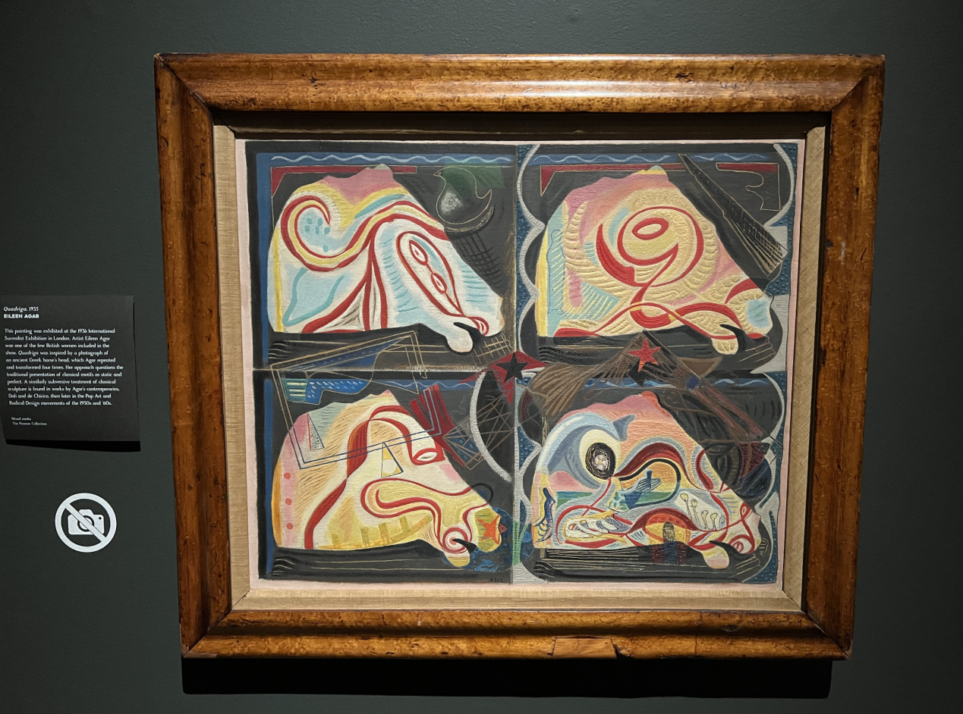

Artists' discourse power refers to their ability to shape the narrative and meaning behind their artwork. Through their artistic practice, artists have the power to communicate their ideas, experiences, and perspectives, and to challenge dominant narratives and perspectives. They also have the power to engage with and influence the discourse around their work, either through direct engagement with audiences or through critical analysis and interpretation by art critics, curators, and scholars.

Knowledge power refers to the authority and influence that comes from possessing knowledge or expertise in a particular field. In the context of art, knowledge power may be held by art critics, curators, and scholars who have expertise in the history and theory of art. These individuals may have the power to shape the discourse around a particular artwork or artist, and to influence public opinion about their work. Overall, both artists' discourse power and knowledge power play important roles in shaping the discourse around art and influencing public opinion about art and its role in society.

If I am a curator or artist, I will provide visitors with opportunities to ask questions and interact, and encourage them to participate in discussions about their works. Encourage diversity of views and expertise. This can create a more inclusive and diverse environment and provide tourists with a richer experience. Accepting disputes and encouraging debate and discussion can also create more attractive and thought-provoking experiences.